SCD Lab 3
22k-5195 Laiba Fatima
Task 1
import javax.swing.*;
import java.awt.event.ActionEvent;
import java.awt.event.ActionListener;
public class task1 extends JFrame {
private JTextField textField1;
private JComboBox comboBox1;
private JCheckBox debateClubCheckBox;
private JButton registerButton;
private JCheckBox scienceFairCheckBox;
private JCheckBox sportsCheckBox;
private JPanel FirstPane;
public task1() {
registerButton.addActionListener(new ActionListener() {
@Override
public void actionPerformed(ActionEvent e) {
JOptionPane.showMessageDialog(registerButton, "Your name: " +textField1.getText() + "\n" + comboBox1.getSelectedItem() + "\n" + (debateClubCheckBox.isSelected() ? debateClubCheckBox.getText() : " ") + (scienceFairCheckBox.isSelected() ? scienceFairCheckBox.getText() : " ") + (sportsCheckBox.isSelected() ? sportsCheckBox.getText() : " "));
}
});
}
public static void main(String[] args) {
task1 f1 = new task1();
f1.setContentPane(f1.FirstPane);
f1.setTitle("Student Registration Form");
f1.setSize(300,300);
f1.setVisible(true);
f1.setDefaultCloseOperation(JFrame.EXIT_ON_CLOSE);
}
}

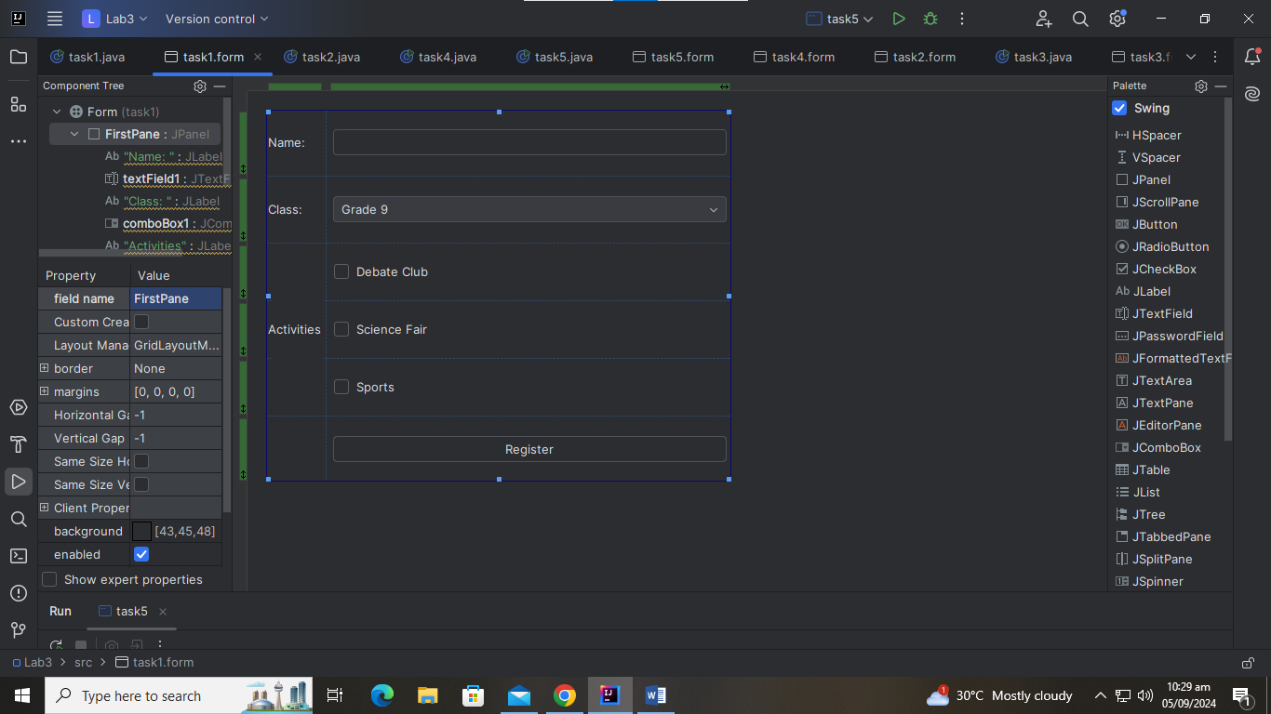
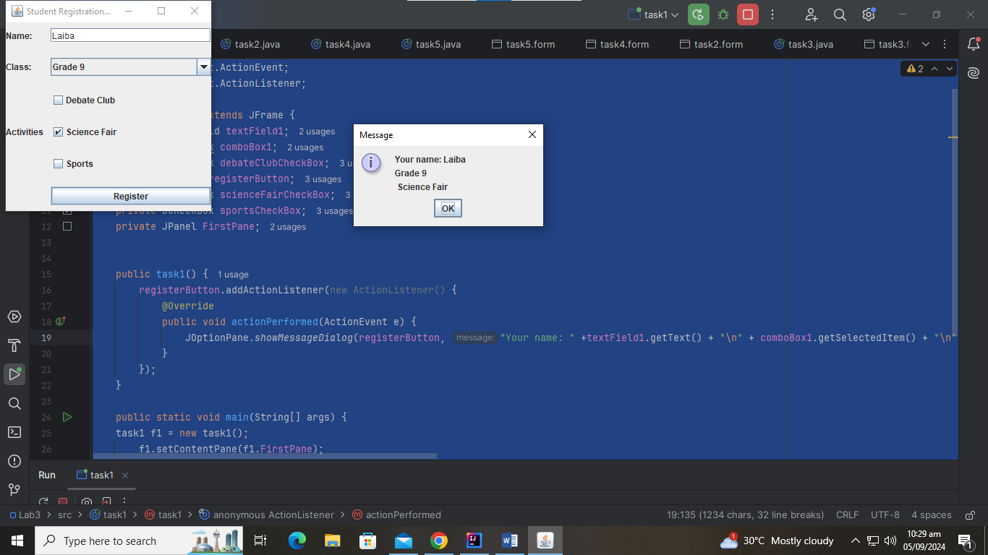

Task 2
import javax.swing.*;
import java.awt.event.ActionEvent;
import java.awt.event.ActionListener;
public class task2 extends JFrame {
private JTextField textField1;
private JButton searchButton;
private JTextArea textArea1;
private JPanel Library;
public task2() {
searchButton.addActionListener(new ActionListener() {
@Override
public void actionPerformed(ActionEvent e) {
textArea1.setText("3 books found matching in '" +textField1.getText() + "'.");
}
});
}
public static void main(String[] args) {
task2 f1 = new task2();
f1.setContentPane(f1.Library);
f1.setTitle("Library Book Search");
f1.setSize(300,300);
f1.setVisible(true);
f1.setDefaultCloseOperation(JFrame.EXIT_ON_CLOSE);
}
}

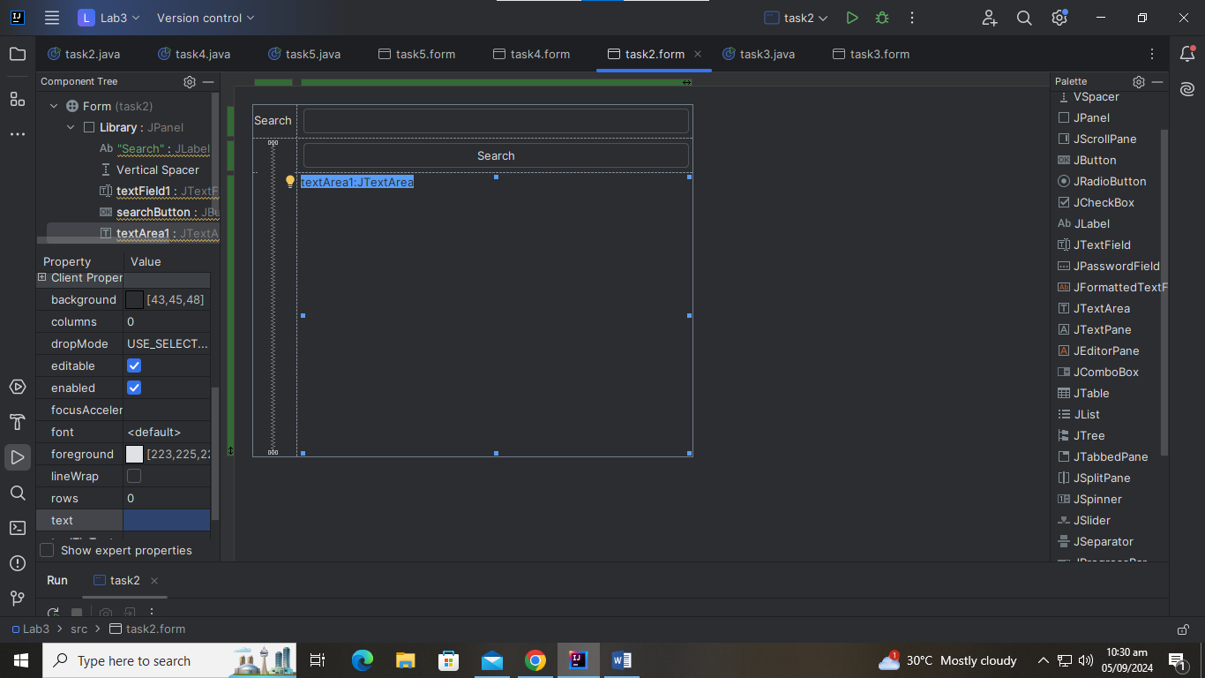
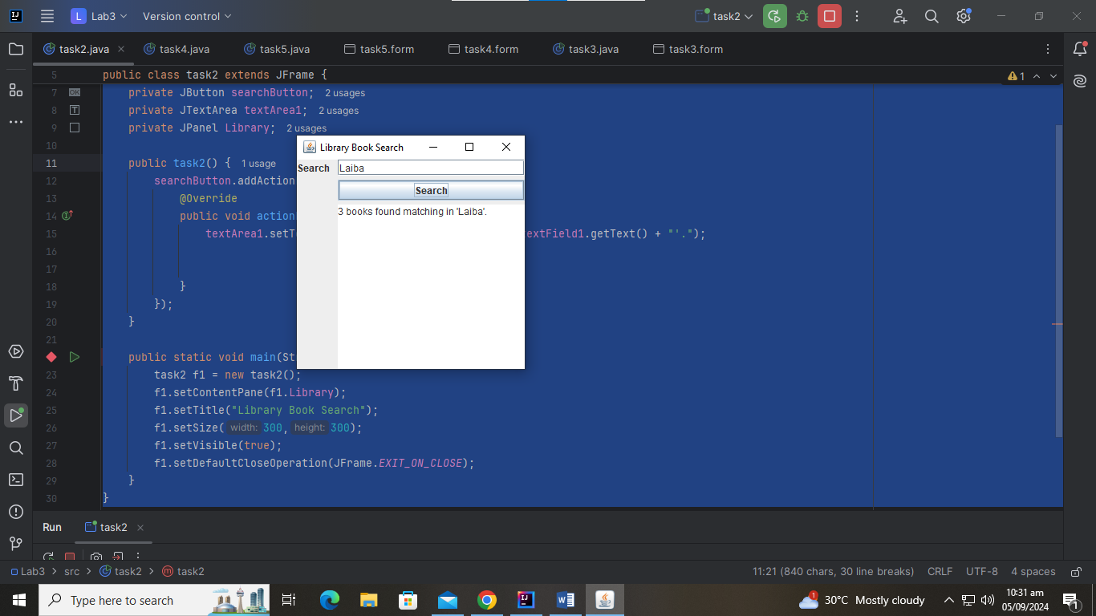

Task 3
import javax.swing.*;
import java.awt.event.ActionEvent;
import java.awt.event.ActionListener;
public class task3 extends JFrame{
private JTextField textField1;
private JTextArea textArea1;
private JComboBox comboBox1;
private JButton submitButton;
private JLabel Feedback;
private JPanel FeedbackForm;
public task3() {
submitButton.addActionListener(new ActionListener() {
@Override
public void actionPerformed(ActionEvent e) {
JOptionPane.showMessageDialog(submitButton, "Thankyou " +textField1.getText() + " for your feedback!\nYour rating was: " + comboBox1.getSelectedItem() + "\nYour commments: " +textArea1.getText());
}
});
}
public static void main(String[] args) {
task3 f1 = new task3();
f1.setContentPane(f1.FeedbackForm);
f1.setTitle("Feedback Form");
f1.setSize(300,300);
f1.setVisible(true);
f1.setDefaultCloseOperation(JFrame.EXIT_ON_CLOSE);
}
}

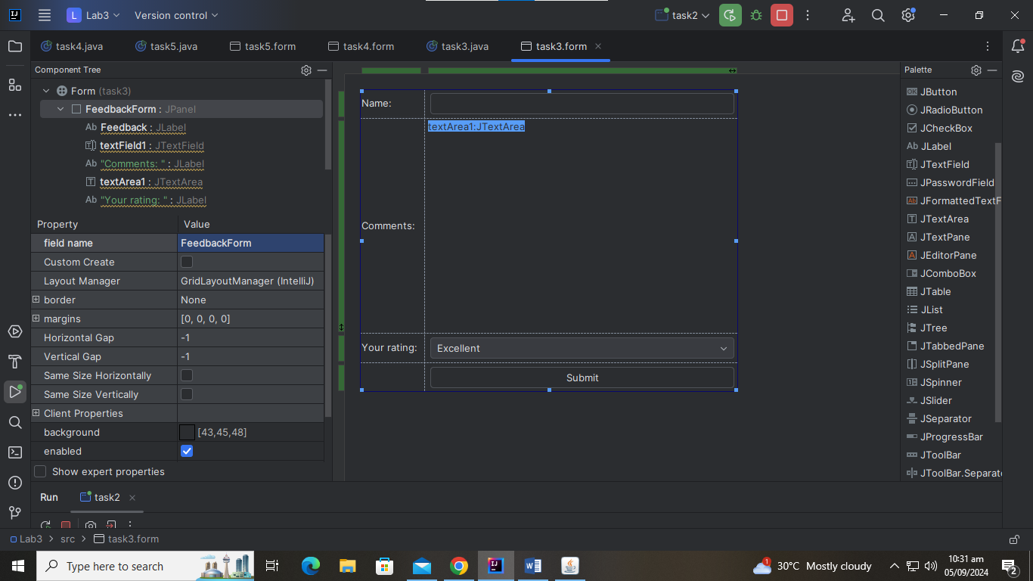
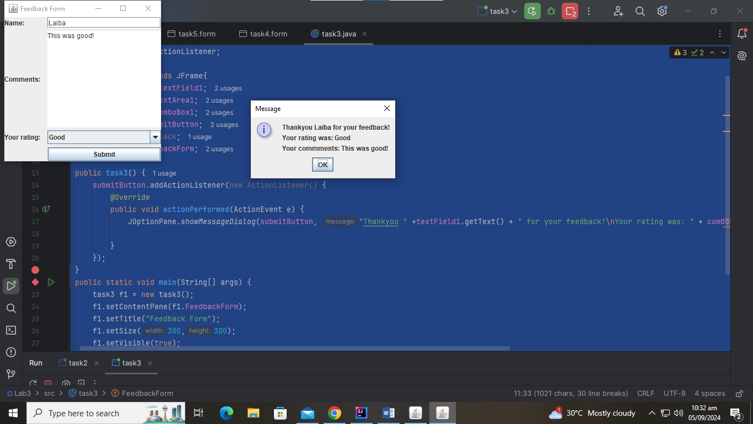

Task 4
import javax.swing.*;
import java.awt.event.ActionEvent;
import java.awt.event.ActionListener;
public class task4 extends JFrame{
private JTextField textField1;
private JPasswordField passwordField1;
private JButton loginButton;
private JPanel StudentLogin;
String username = "laiba";
String password = "abc";
public task4() {
loginButton.addActionListener(new ActionListener() {
@Override
public void actionPerformed(ActionEvent e) {
if((textField1.getText().equals(username)) && (passwordField1.getText().equals(password))){
JOptionPane.showMessageDialog(loginButton, "Login Success! :)");
}
else{
JOptionPane.showMessageDialog(loginButton, "Login Failed! :(");
}
}
});
}
public static void main(String[] args) {
task4 f1 = new task4();
f1.setContentPane(f1.StudentLogin);
f1.setTitle("Library Book Search");
f1.setSize(300,300);
f1.setVisible(true);
f1.setDefaultCloseOperation(JFrame.EXIT_ON_CLOSE);
}
}

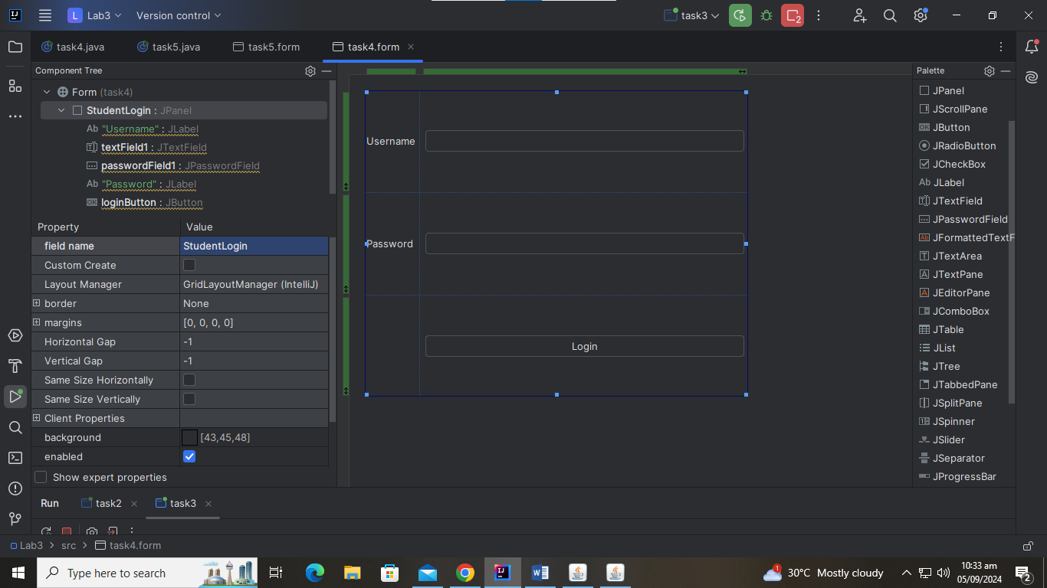
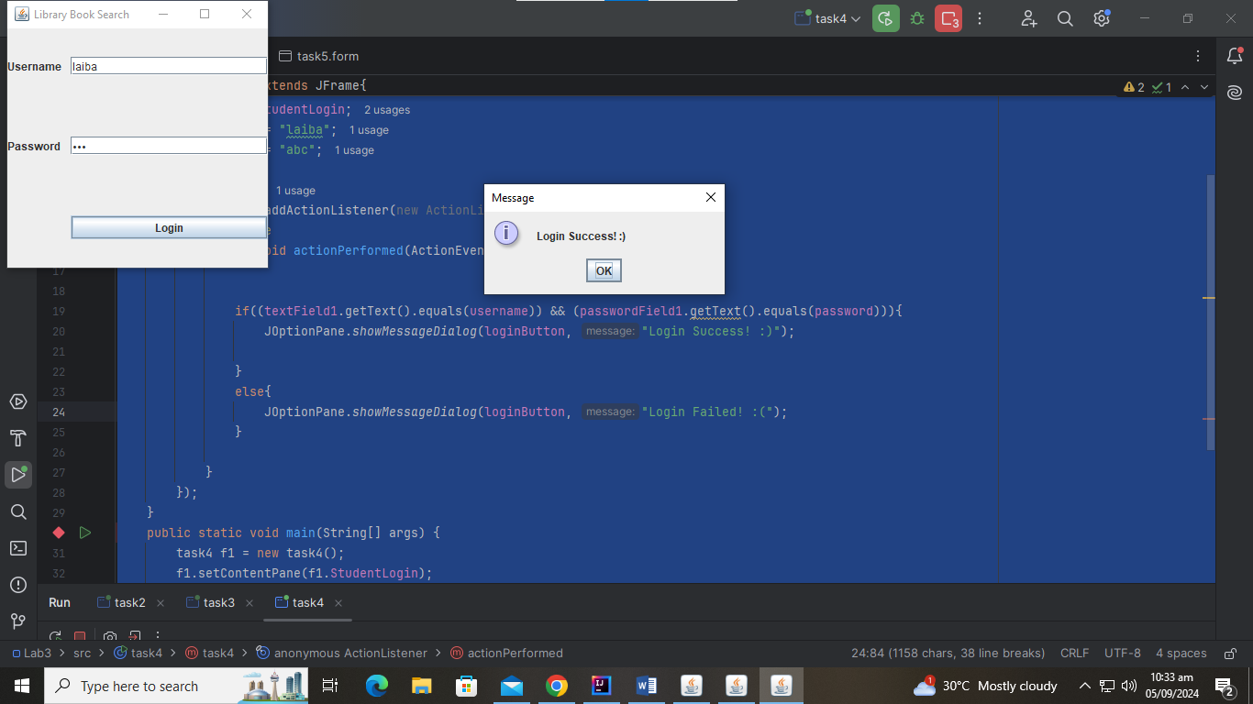
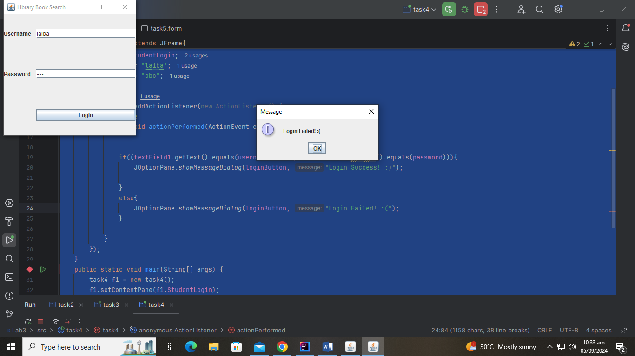

Task 5
import javax.swing.*;
import java.awt.event.ActionEvent;
import java.awt.event.ActionListener;
public class task5 extends JFrame {
private JTextField textField1;
private JComboBox comboBox1;
private JSpinner spinner1;
private JButton placeOrderButton;
private JPanel Canteen;
public task5() {
placeOrderButton.addActionListener(new ActionListener() {
@Override
public void actionPerformed(ActionEvent e) {
JOptionPane.showMessageDialog(placeOrderButton, textField1.getText() + ", you have ordered " + spinner1.getValue() +comboBox1.getSelectedItem());
}
});
}
public static void main(String[] args) {
task5 f1 = new task5();
f1.setContentPane(f1.Canteen);
f1.setTitle("Library Book Search");
f1.setSize(300,300);
f1.setVisible(true);
f1.setDefaultCloseOperation(JFrame.EXIT_ON_CLOSE);
}
}

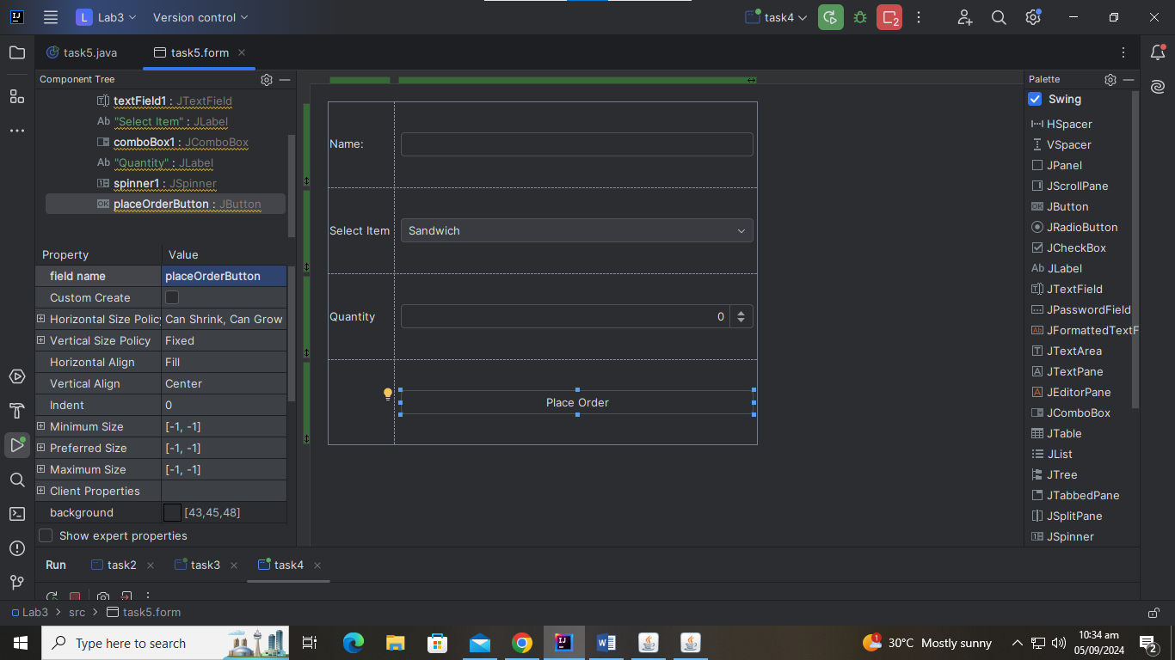
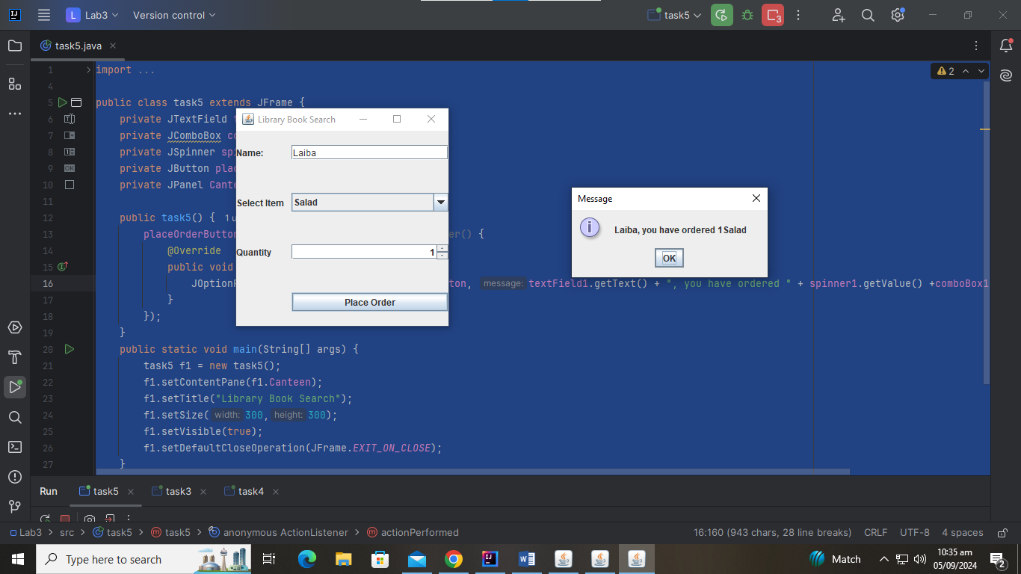

Task 6
import javax.swing.*;
import java.awt.event.ActionEvent;
import java.awt.event.ActionListener;

public class task6 extends JFrame{
private JPanel LOGIN;
private JPasswordField passwordField1;
private JTextField textField1;
private JButton signInButton;
String username = "22k-5195";
String password = "a";

public task6() {
signInButton.addActionListener(new ActionListener() {
@Override
public void actionPerformed(ActionEvent e) {
if((textField1.getText().equals(username)) && (passwordField1.getText().equals(password))){
dispose();
register f2 = new register();
f2.setContentPane(f2.Dashboard);
f2.setTitle("FlexStudents");
f2.setSize(300,300);
f2.setVisible(true);

}
else{
JOptionPane.showMessageDialog(signInButton, "Username or password invalid! ");
}

}
});
}

public static void main(String[] args) {
task6 f1 = new task6();
f1.setContentPane(f1.LOGIN);
f1.setTitle("FlexStudents");
f1.setSize(300,300);
f1.setVisible(true);
f1.setDefaultCloseOperation(JFrame.EXIT_ON_CLOSE);

}

}

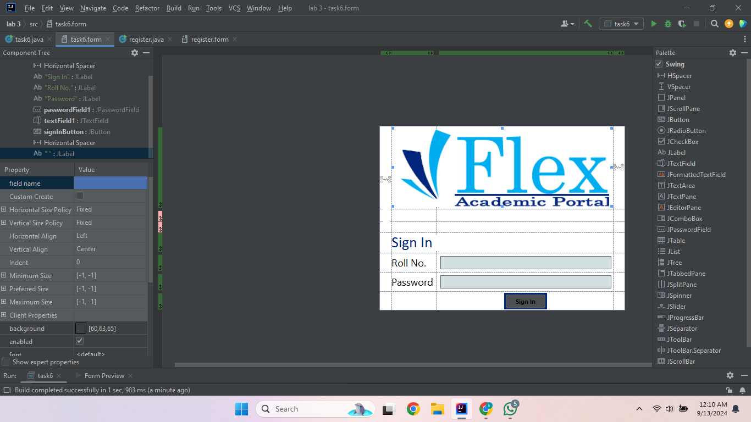
import javax.swing.*;
import javax.swing.JFrame;
import java.awt.event.ActionEvent;
import java.awt.event.ActionListener;

public class register extends JFrame {
public JPanel Dashboard;
private JTabbedPane tabbedPane1;
private JComboBox comboBox1;
private JComboBox comboBox2;
private JComboBox comboBox3;
private JButton registerButton;
private JTextArea textArea1;
private JComboBox comboBox4;
private JButton updateButton;

String course1, course2, course3;

private void validateCourseSelection() {

course1 = (String) comboBox1.getSelectedItem();
course2 = (String) comboBox2.getSelectedItem();
course3 = (String) comboBox3.getSelectedItem();

if (course1.equals(course2) || course1.equals(course3) || course2.equals(course3)) {
JOptionPane.showMessageDialog(registerButton, "Please select different courses for each selection!", "Duplicate Courses", JOptionPane.ERROR_MESSAGE);
} else {
JOptionPane.showMessageDialog(registerButton, "Go to 'View' tab", "Success", JOptionPane.INFORMATION_MESSAGE);
textArea1.setText(course1 +"\n" + course2 +"\n" + course3);

comboBox4.removeAllItems();
comboBox4.addItem(course1);
comboBox4.addItem(course2);
comboBox4.addItem(course3);

}
}

public register( ){
setTitle("FlexStudents");
setContentPane(Dashboard);
setSize(300,300);
setVisible(true);
setDefaultCloseOperation(JFrame.EXIT_ON_CLOSE);

textArea1.setEditable(false);

registerButton.addActionListener(new ActionListener() {
@Override
public void actionPerformed(ActionEvent e) {
validateCourseSelection();

}
});
updateButton.addActionListener(new ActionListener() {
@Override
public void actionPerformed(ActionEvent e) {
String courseToDrop = (String) comboBox4.getSelectedItem();

if (courseToDrop != null) {
comboBox4.removeItem(courseToDrop);

StringBuilder updatedCourses = new StringBuilder();

if (!course1.equals(courseToDrop)) {
updatedCourses.append(course1).append("\n");
}
if (!course2.equals(courseToDrop)) {
updatedCourses.append(course2).append("\n");
}
if (!course3.equals(courseToDrop)) {
updatedCourses.append(course3).append("\n");
}

textArea1.setText(updatedCourses.toString());
JOptionPane.showMessageDialog(updateButton, "Go to 'View' tab", "Success", JOptionPane.INFORMATION_MESSAGE);
} else {
JOptionPane.showMessageDialog(updateButton, "No course selected to drop!", "Error", JOptionPane.ERROR_MESSAGE);
}
}
});
}

public static void main(String[] args) {
register f2 = new register();

}
}

